Prototype-Midterm

|  |  |
| --- | --- |
| **Student Name/ID Number:** | Francis Roel L. Abarca – BDSE-0922-113 |
| **Academic Year:** | 2022-2023 |
| **Unit Assessor:** | Arvinder Kaur |
| **Project Title:** | CPL-Midterm |
| **Issue Date:** | 9/8/2023 |
| **Submission Date:** | 9/16/2023 |
| **Internal Verifier Name:** | Arvinder Kaur |
| **Date:** | 9/8/2023 |

|  |
| --- |
| **Learner declaration** |
| I certify that the work submitted for this assignment is my own and research sources are fully acknowledged.    9/8/2023  Student signature: Date: |

1. A summary of the project's objectives, scope, and requirements, as outlined in the project brief or proposal.

**Project Objectives:**

The project’s primary goal is to design and implement a self-hosted AI chatbot for Jumpstart. This chatbot will use LLaMA 2 to integrate with Jumpstart’s REST API, providing information about stock and product descriptions. The chatbot will be evaluated and tested with real users, with the feedback and metrics analyzed to measure customer satisfaction, engagement, and loyalty. The project will also explore successful AI chatbots in retail, such as those used by H&M and Tommy Hilfiger, with the chatbot running on our own systems for greater security and control.

The project’s scope includes understanding the benefits and challenges of using AI chatbots in retail, designing and implementing the chatbot prototype, evaluating its performance with real users, and studying successful examples in the industry. The objectives are to review existing research on AI chatbots in retail, identify key features for a successful chatbot, develop a prototype for Jumpstart using LLaMA 2, and provide recommendations for improvement.

The project requirements include using ReactJS for the front-end development, a Ryzen 7 System costing around $300, Spring Boot for the application framework, and MySQL Server for the database management system.

**Project Scope:**

The scope for this project include:

* The benefits and challenges of utilizing AI chatbots for retail customer sevice such as reducing costs, increasing efficiency, personalizing interactions and building trust.
* The design and implementation of an AI chatbot prototype for Jumpstart, using LLaMA 2 to integrate with their REST API and provide information about stock and product description.
* The evaluation and testing of the AI chatbot prototype with real users, and the analysis of the feedback and metrics to measure customer satisfaction, engagement, and loyalty.
* The best practices and examples of successful AI chatbots in retail, such as those utilized by H&M, Tommy Hillfiger and the like on how they use AI to provide advice to users, helpful comparisons and product recommendations.

**Project Requirements:**

The requirements of this project include:

* Hardware:
  + AMD Ryzen 7 5800H Mini-PC = $300 USD
* Software:
  + MySQL Server 8.0
  + Windows 11, macOS Ventura, Ubuntu 23.04
  + GPT4All
  + LLaMA 2
  + ReactJS
  + Node.js
  + Spring Boot
  + IntelliJ IDEA Ultimate
  + Spring Tool Suite
  + Python 3.11.0

1. A brief description of the technologies, programming languages, and frameworks used to develop the website.
   * MySQL Server 8.0

* MySQL Server 8.0 is a robust SQL (Structured Query Language) database server intended for mission-critical, heavy-load production systems. It is created by Oracle and is an open-source product licensed under GNU. This is used to handle the back-end database storage for the project.
  + Windows 11
* Windows 11 is an operating system created by Microsoft which introduces a new interface complete with a centered Start Menu and rounded corners. Other than the interface, Windows 11 also hosts new back-end technologies like Hyper-V GPU Paravirtualization which allows virtual machines to have access to a system’s GPU for 3D work.
  + macOS Ventura
* macOS Ventura is Apple’s latest operating system. This operating system is used for the designing for the front-end, testing, scheduling and a lot of the development work. macOS’s tools like Pages, UNIX-based Terminal, phenomenal user experience and support for iOS development allows developers to easily perform these tasks with ease.
  + Ubuntu 23.04
* Canonical’s new flavor of Ubuntu, Lunar Lobster, offers a better experience for Linux users. This operating system is based on Linux and designed to mostly handle server-side work. Ubuntu Server has been praised for its top-tier reliability, efficiency and speed.
  + GPT4All
* GPT4All is a text-generative software which is used to easily deploy and utilize Self-Hosted AI applications.
  + LLaMA 2
* LLaMA 2 is a second-generation open-source large language model (LLM) from Meta. It is what’s used in the project as the main chatbot system.
  + ReactJS
* ReactJS is a popular open-source JavaScript library. It is an alternative to Angular and Flutter and is used to build front-end interfaces for Web Applications.
  + Node.js
* Node.js is a JavaScript runtime environment that is responsible for handling ReactJS and is mainly designed to build scalable network applications in an asynchronous event-driven manner.
  + Spring Boot
* Pivotal’s Spring Boot makes it easy to create stand-alone, production-grade Spring based Applications that you can “just run”. It takes an opinionated view of the Spring platform and third-party libraries so you can get started with minimum fuss. This is used to handle the back-end and authentication services for the project.
  + IntelliJ IDEA Ultimate
* Jetbrains’s IntelliJ IDEA Ultimate is a full-featured Java and Kotlin IDE that provides everything you need out of the box, including built-in developer tools such as database tools and profilers, web and enterprise frameworks, remote development, and much more. This IDE is used to write and execute Spring Boot code to handle the back-end technologies for this project.
  + Visual Studio Code
* Microsoft’s popular text editor, Visual Studio Code, is a lightweight but powerful source code editor that runs on Windows, macOS, Linux. It has support for editing JavaScript, TypeScript, and Node.js and has a rich ecosystem of plugins for other languages, runtimes and extensions which can be utilized to speed up and optimize development. In this case, Visual Studio Code is used to develop the ReactJS and Python code for the project.
  + Java
* Java is a high-level programming language developed by Sun Microsystems (now owned by Oracle). It is an object-oriented and class-based language designed to have few implementation dependencies as possible.
  + JWT (JSON Web Tokens)
* JWT is an open standard (RFC 7519) system that defines a compact and self-contained way for securely transmitting information between parties as a JSON object. This information can be verified and trusted because it utilizes digital signatures. In the project, this is used to handle the login systems and secure transactions of user credentials for both the front-end and back-end systems.
  + Bootstrap
* Bootstrap is a free and open-source CSS framework directed at responsive, mobile-first front-end web development. It contains CSS- and JavaScript-based design templates for typography, forms, buttons, navigation, and other interface components. In the project, Bootstrap is used to handle the interface design to ensure equal and responsive design for everyone.
  + APIs
* An API, or Application Programming Interface, is a set of rules that enable different applications to communicate with each other. It acts as an intermediary layer that processes data transfers between systems, letting companies open their application data and functionality to external third-party developers, business partners and internal departments within their companies.
  + RESTFul APIs:
* RESTFul API is an interface that two computer systems use to exchange information securely over the internet. Most business applications have to communicate with other internal and third-party applications to perform various tasks. RESTFul APIs support this information exchange because they follow secure, reliable, and efficient software communication standards. In this project. APIs are used to handle the registration and other transaction-based systems.
  + Python
* Python is an interpreted, object-oriented, high-level programming language with dynamic semantics. Its high-level built-in data structures, combined with dynamic typing and dynamic binding, make it very attractive for Rapid Application Development, as well as for use as a scripting or glue language to connect existing components together.
  + Flask
* Flask is a micro web framework written in Python. It is considered as a microframework because it does not require particular tools or libraries. It has no database abstraction layer, form validation, or any other components where pre-existing third-party libraries provide common functions. However, Flask supports extensions that can add application features as if they were implemented in Flask itself.

1. Design and other design assets that illustrate the website's layout, color scheme, typography, and overall user interface design.

* Login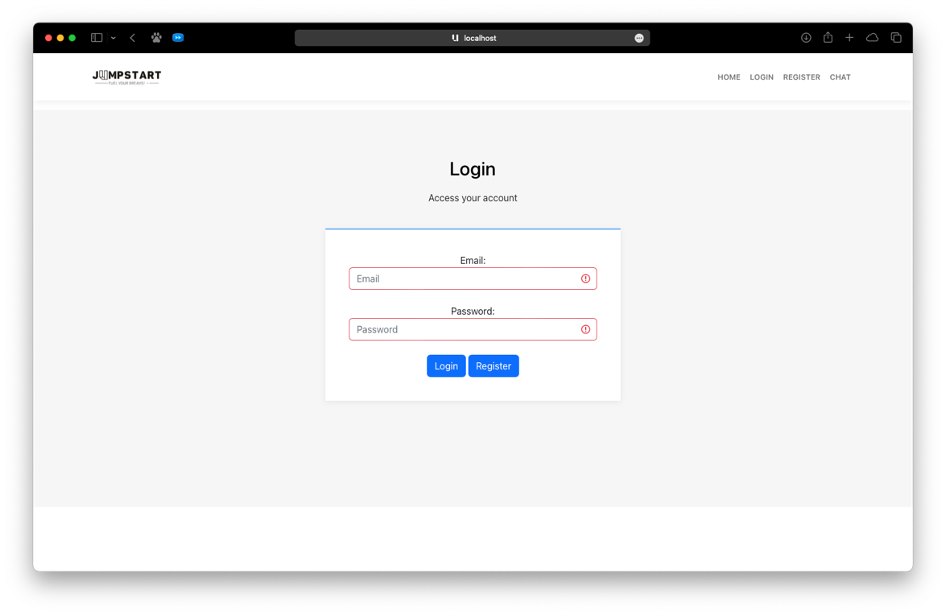
* Registration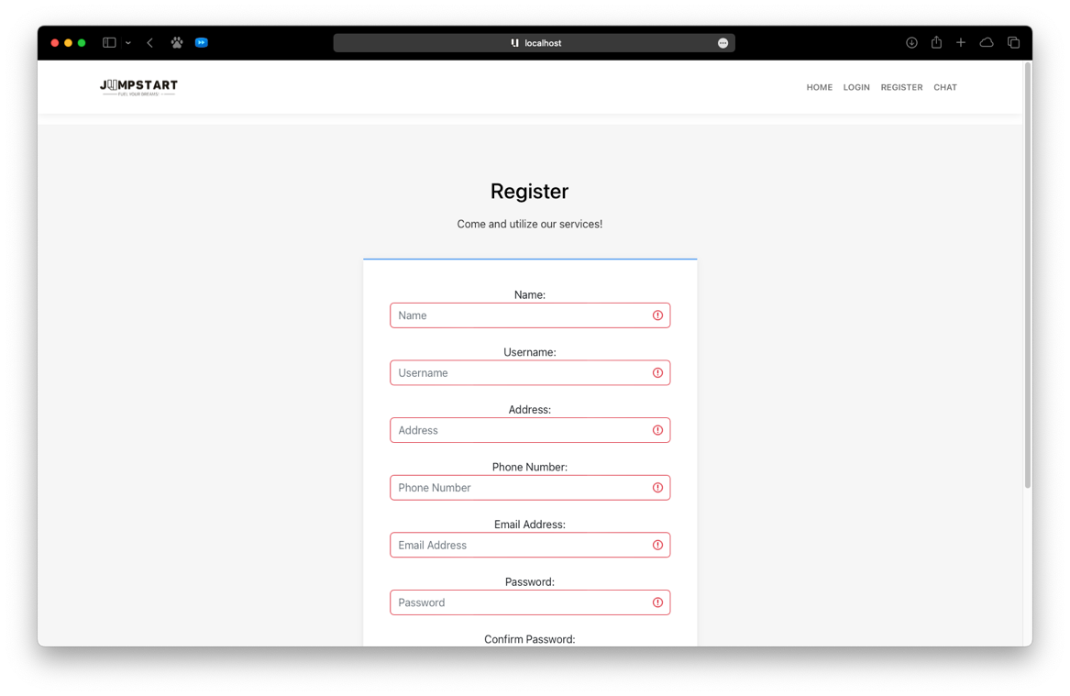

1. A description of the website's core functionality and features that have been implemented so far, along with any that are planned for the remaining development period.

* Login
  + - This allows the user to log onto the website and ensure the cart and systems are tailored to their use.
* Registration
  + - This allows the user to register to the said website as a member.
* Add Product
  + - This allows the staff of the page (in this case, the back-end developers) to easily add products to the page.
* Display Product
  + - This allows customers to easily view a product in its glory.
* View Category
  + - This allows customers to easily check specific categories for specific products.

1. Sample code snippets and database schemas that showcase the website's back-end functionality.

* Registration
  + - Source Code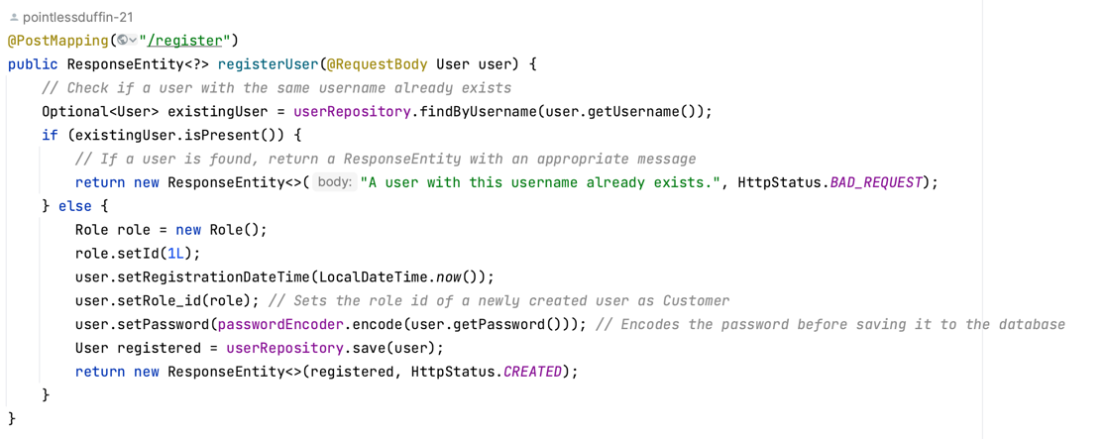
    - Database Schema
      * User  
        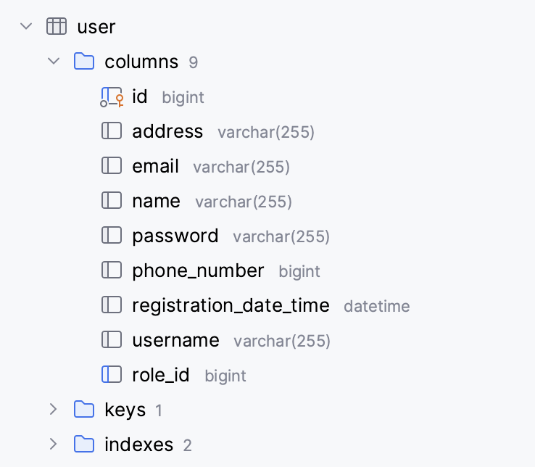
      * Role  
        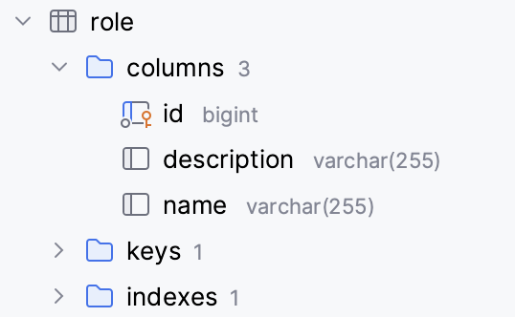
* Login  
  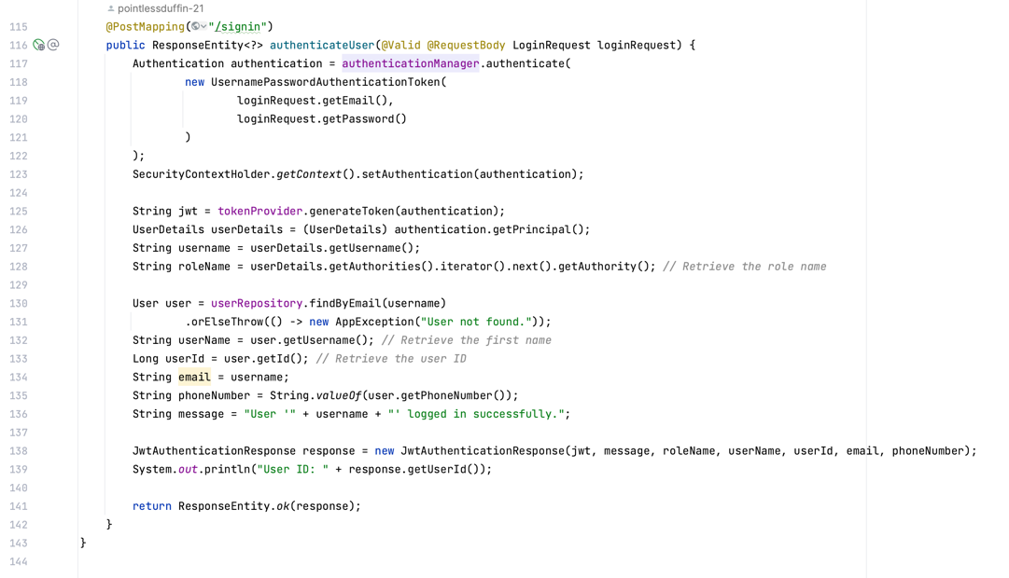
* Add Product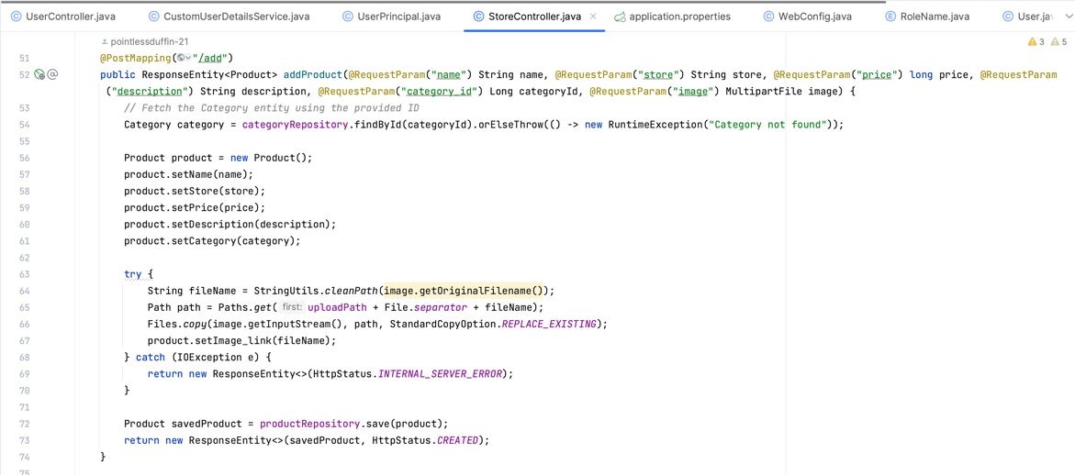
* Add Category  
  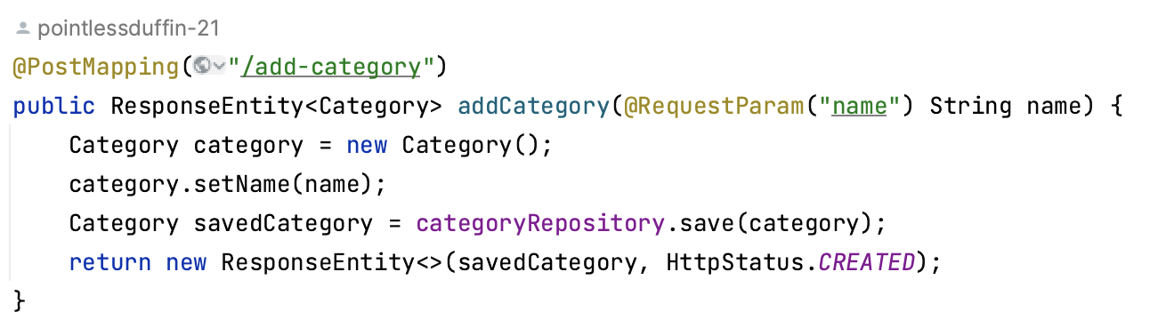
* View Category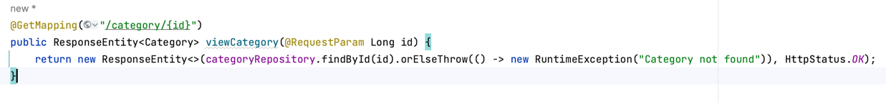
* Delete Product  
  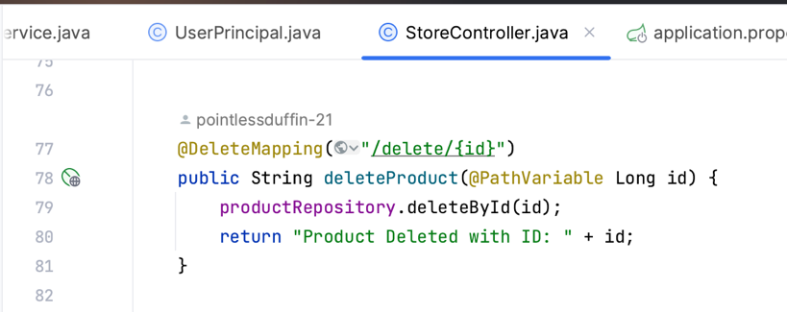
* View All Product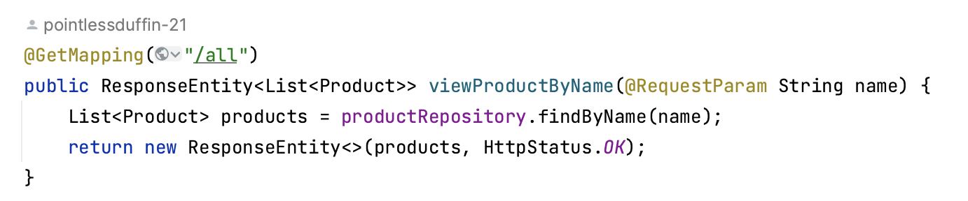
* View Product by ID

1. A detailed roadmap or timeline for the remaining tasks and deliverables, along with any changes or updates to the original project plan.

* Tasks Finished
  + - Project Initiation
    - Requirements Gathering
    - UI/UX Design
    - Back-End Development
* Tasks to be worked on:
  + - AI Integration
    - Front-End Development
    - Alpha Testing
    - Final Evaluation
    - Finalization
    - Deployment

